Advanced Games Programming
Tutorial 03 - Using Vertex Buffers and Shaders to Render

Introduction

The previous tutorials in this unit focussed on setting up a Windows application that was capable of using Direct3D for rendering. The next step will be to draw to the screen using Direct3D, and for this you will need to learn about vertex buffers and shaders.

Vertex buffers

A vertex defines the position of a point in 3D space, along with optional additional data, such as a colour or texture coordinates. Any given 3D model will be made from a list of vertices that define its shape. A vertex buffer is the resource that Direct3D uses to store the list of vertices that make up an object, in a format that allows Direct3D to send the vertices to the graphics hardware efficiently.

A vertex is defined using a struct to determine what elements make up the vertex. Here is a simple vertex that represents position and colour:

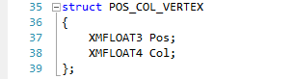

The XMFLOAT3 type represents 3 floats, in this case x, y and z for a 3D position, and XMFLOAT4 represents 4 floats, for this an rgba colour. In Direct3D the basic primitive shape is the triangle, and vertices are used to define the triangles that represent an object. Here is a 3 element array that represents a triangle, each has a different position and a different colour:

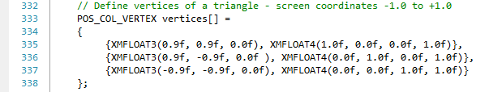

Shaders

Shaders are essentially programs that run on graphics hardware. There are a number of different types of shader, but to begin with you only need to know about vertex shaders and pixel shaders.

A vertex shader is a program that processes vertex data, and so runs once per vertex. The input vertex data is processed by the vertex shader, which then outputs the modified vertices. These modifications can be anything, such as transforming the vertex from 3D space onto a 2D screen, manipulating colour values for lighting effects, modifying texture coordinates and much more.

A pixel shader is a program that processes individual screen pixels. The triangles that are formed from the modified vertices from the vertex shader output are drawn on the screen (if visible) pixel by pixel. The values of the vertex data are interpolated across the triangle for each pixel, for instance if one vertex was red and another green then the colour values of the pixels that lie between the two vertices would vary smoothly from red to green.

Here you can see the effect of interpolation with 3 vertices, one red, one green and one blue:



If a pixel is visible then the pixel shader processes the interpolated pixel data to calculate the final pixel colour.

Tutorial 03 Exercise 01 - Create a vertex buffer, vertex shader, pixel shader and draw a triangle
- Create a new project based on your Tutorial 02 Exercise 01 project (or one of the extra/advanced exercises), renaming it in the correct way.
- [If new project based on Extra 01 or 02] Remove any code that was used to adjust the background clear colour.
- Add the following to the headers section:
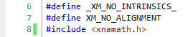
this includes the XNA maths library, which DirectX shares with XNA. The #defines tell the compiler to use less optimal but more compatible code. The optimised version requires data in XMVECTOR and XMMATRIX structures to be correctly aligned, and this can cause major and difficult to diagnose crashing issues if not done correctly, especially on 64 bit machines. You should precede all xnamath.h includes with these defines until you are sure you know what you are doing.
- Add the following variables and structure definition to the globals section:
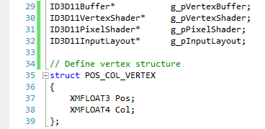
- Add this function definition to the forward declaration section:

- After InitialiseD3D(), call InitialiseGraphics():
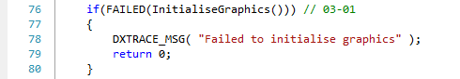
- In RenderFrame() add the following after ClearRenderTargetView():
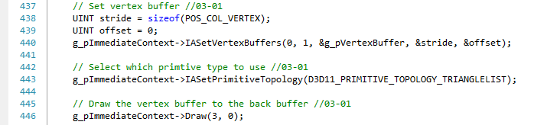
IASetVertexBuffers() sets the active vertex buffer, and IASetPrimitiveTopology()the way vertices are used to draw triangles. Draw() actually draws the object in the vertex buffer, the first parameter is how many vertices to draw, and the second where in the vertex buffer to start from, 0 means the start.
- Add the following function, just before RenderFrame() :
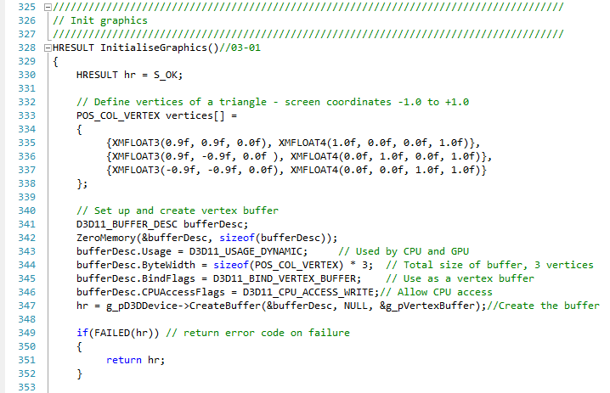
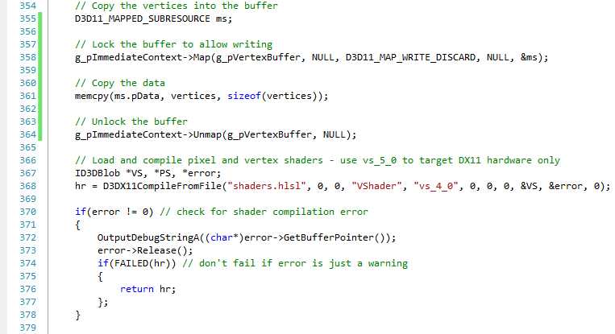
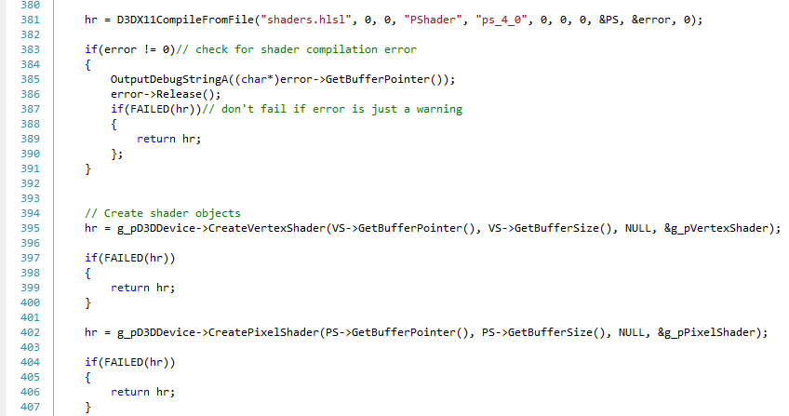
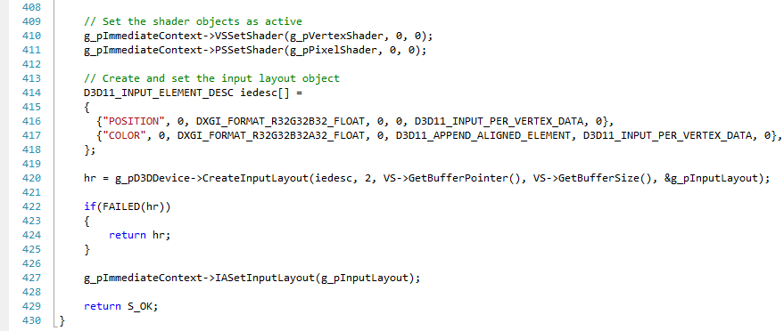
- Add the following to the start of ShutdownD3D(). Be careful to put these before the other Release() calls, otherwise you'll be releasing resources that were used to create these objects before the objects themselves, which can lead to resources not being correctly freed:
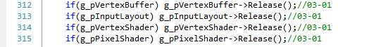

- Add a new file to your project called shaders.hlsl (choose Project->Add new item, add a .txt file in project, call it shaders.hlsl in the name field), add the following shader code and save it. Don't worry for now exactly what things mean, this will become clearer in later tutorials.
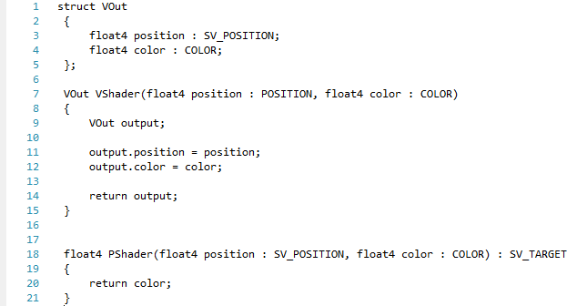

Some of the previous code will now be analysed in more detail.

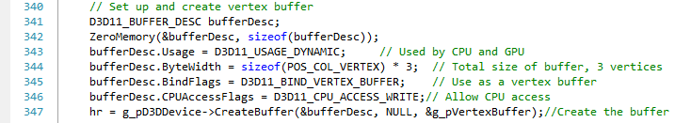

This code creates the vertex buffer that will hold the vertices to be drawn. It uses a D3D11_BUFFER_DESC which defines the properties of the vertex buffer. The Usage field tells Direct3D how the buffer will be used, in this case D3D11_USAGE_ DYNAMIC means that both CPU and GPU access is allowed. This is a convenient way of using the buffer during tutorials, but is not necessarily the most optimal; in a commercial game most vertex buffers would not be accessible by the CPU at all for performance benefits. The CPUAccessFlags field is set to D3D11_CPU_ACCESS_WRITE to allow the CPU access.

The ByteWidth field represents the total size of the buffer needed in bytes. This needs to be able to hold the required number of vertices, so the size is calculated from the size of a single vertex multiplied by the number of vertices, in this case 3. The BindFlags field to D3D11_BIND_VERTEX_BUFFER simply tells Direct3D that this is a vertex buffer.

The CreateBuffer() function creates the buffer. The first parameter is the address of the properties struct shown above. The second parameter allows vertex data to be added to the buffer on creation, this is useful when the buffer has no CPU access defined but it is set to NULL as you can add vertex data later when using a dynamic buffer. The third parameter is the address of the buffer object that is returned on successful creation.

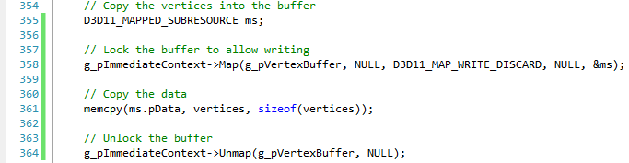

In order to add vertices to the vertex buffer there needs to be some mechanism to give the CPU access to it. In Direct3D this is done using the Map() and Unmap() methods of the device context. The Map() method uses a pointer to a vertex buffer in the first parameter to return data about the location of the buffer for the CPU to access in a structure of type D3D11_MAPPED_SUBRESOURCE in the fourth parameter. The other two parameters are for advanced use, don't worry about them just yet.

Once the location of the buffer is returned, a simple memcpy() can be used to copy the vertex data into the vertex buffer. Once this is done Unmap()needs to be used to tell Direct3D that the copy has finished and that it is free to use the buffer again.

These functions are used to load the shaders from a file and compile them into a format that the GPU understands. Most of the parameters are irrelevant at this point, so just the pertinent ones will be discussed.

The first parameter is the filename where the shaders are, in this case it is a .hlsl file (HLSL means high level shading language, and this is the language shaders are written in).

The fourth parameter is the name of the shader in that file that you want to compile - there can be several per file.

The fifth parameter is the target pixel shader version for the compilation of the shader, ps_4_0 for Direct3D10 level hardware and up, ps_5_0 for Direct3D11 and higher.

The ninth parameter will return an ID3DBlob that contains the compiled shader code. An ID3DBlob is just an object that stores a buffer of data.

The tenth parameter is another blob returned, this time containing error messages if the shader fails to compile.

These two functions take the compiled shaders and create vertex and pixel shaders that are returned in the respective global variables, these shaders are then set as the active shaders:

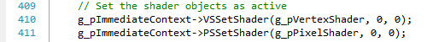

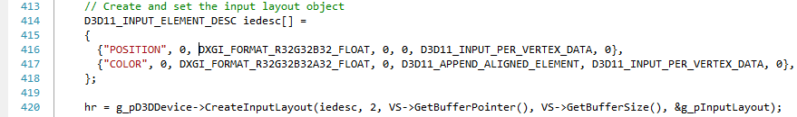

The final part of setting up the shaders and vertex buffers is to tell Direct3D the format of the vertices we have loaded so that it can correctly interpret them. This is done using an input layout, which is a list of the elements of a vertex described by a D3D11_INPUT_ELEMENT_DESC description. Each element consists of seven values that describe that element, e.g.

The first value is the semantic, which tells the GPU what the value is used for. In this case it is a POSITION, so the GPU will know to treat this element as positional type of data and is linked to the HLSL shader input and output variables. The second value is the semantic index, so if a vertex had two colours, they could both use the COLOR semantic, but a different index to differentiate them.

The third value is the format of the data, this needs to match what was used to create the vertices, in this case a three element float DXGI_FORMAT_R32G32B32_FLOAT.

The fourth value is called the input slot. For now, it should be 0.

The fifth value indicates how many bytes into the struct the element is. This is called the offset. In this example the position has an offset of 0, this means the position starts 0 bytes into the struct. You can manually specify the value of the offset for subsequent elements (for instance you may want gaps in the data) but usually it is simpler to use D3D11_APPEND_ALIGNED_ELEMENT, which tells Direct3D to calculate and set the value automatically.

The sixth value is what the element is used as. For now just use D3D11_INPUT_PER_VERTEX_DATA. The seventh value is not needed yet.

CreateInputLayout() uses this structure to return an input layout into the g_pInputLayout global, and then this input layout is set using IASetInputLayout().

